RISC-V32I Single-Cycle CPU Documentation
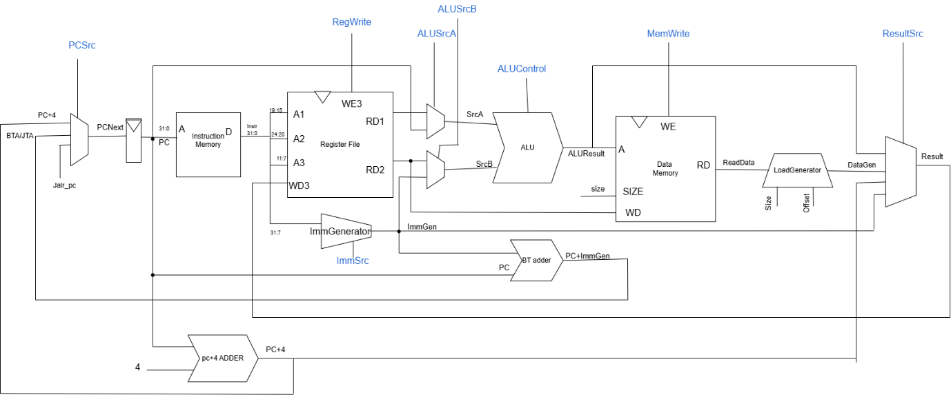
Instr | Opcode | RegWrite | ImmSrc | ALUSrcA | ALUSrcB | MemWrite | ResultSrc | Branch | ALUOP | Jump | Jalr
Load | 0000011 | 1 | 000 | 0 | 1 | 0 | 01 | 0 | 00 | 0 | 0
Store | 0100011 | 0 | 001 | 0 | 1 | 1 | xx | 0 | 00 | 0 | 0
R-type | 0110011 | 1 | xxx | 0 | 0 | 0 | 00 | 0 | 10 | 0 | 0
Branch | 1100011 | 0 | 010 | 0 | 0 | 0 | xx | 1 | 01 | 0 | 0
I-type | 0010011 | 1 | 000 | 0 | 1 | 0 | 00 | 0 | 10 | 0 | 0
Jal | 1101111 | 1 | 011 | x | X | 0 | 10 | 0 | xx | 1 | 0
Jalr | 1100111 | 1 | 000 | 0 | 1 | 0 | 10 | 0 | 00 | 0 | 1
Auipc | 0010111 | 1 | 100 | 1 | 1 | 0 | 00 | 0 | 00 | 0 | 0
Lui | 0110111 | 1 | 100 | 0 | x | 0 | 11 | 0 | Xx | 0 | 0
Main Decoder truth table

Cheat Tables:
Mux ALUSrcA
0 | 1
RD1 | PC
Mux ALUSrcB
0 | 1
RD2 | ImmGen

Mux PC’ (PCSrc)
00 | 01 | 10
RD1 | PC
Mux ResultSrc
00 | 01 | 10 | 11
ALUResult | DataGen | PC+4 | ImmGen

ALUOp | Definition
00 | Add
01 | Sub
10 | Look at opcode,funct7,funct3
11

ALU Decoder truth table
ALUOp | Funct3 | Funct2 | ALUControl | Instr
00 | xxx | xx | 0000(add) | All -load ,auipc,Jalr
01 | xxx | xx | 0001(sub) | All b-type
10 | 000 | 00,10,01 | 0000(add) | Addi,add,x
10 | 000 | 11 | 0001(sub) | sub
10 | 001 | 00,10 | 0010(sll) | Slli,sll
10 | 010 | 10,0x | 0011(slt) | Slt,slti
10 | 011 | 0x,10 | 1011(sltu) | Sltiu,sltu
10 | 100 | 0x,10 | 0100(xor) | Xori,xor
10 | 101 | 00,10 | 0101(srl) | Srli,srl
10 | 101 | 01,11 | 1101(sra) | Srai,sra
10 | 110 | 0x,10 | 0110(or) | Ori,or
10 | 111 | 0x,10 | 0111(and) | Andi,and

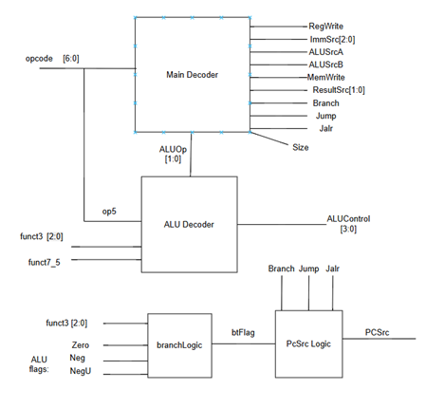

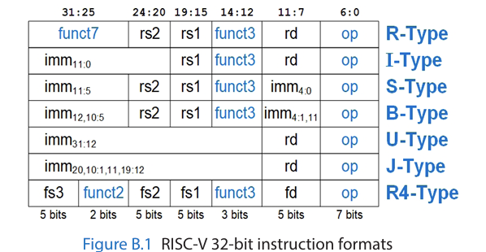

L-type Load Instructions (opcode 3)
Loading data from memory to register file.
Implemented ImmGenerator – given type of instruction locates the immediate within the instruction and sign extend it to 32 bit.
Implemented LoadGenerator to distinguish between lb/lw/lh/lbu/lhu.
The load generator outputs the selection (word/half/byte) sign/zero extended to 32bit.
The distinguish is easily selected by ‘Size’ = funct3 control bits.
In Load we use the ALU to calculate address –
ALUResult [31:2] = word address, ALUResult[1:0] is the byte address.
So we can know the actual byte location.

S-type Store Instruction (opcode 35)
Storing data from register file onto data memory.
Rs2 is the target address. Rs1+imm is source.
Size is given again by funct3 control bits.
The distinguish between sb/sh/sw is implemented in the Data Memory module.

R-type (opcode 51) and I-type (opcode19) instructions
Those instructions are heavy about ALU , mainly difference that ‘b’ is a register in R type and in I type ALU’s ‘b’ is sign extended imm.
The operations are mostly distinguished by funct3 , although add/sub and srl/sra distinguished by funct7. (the leftmost 2nd bit is enough = funct7_5).
To distinguish R-type from immediate alu operations (aaddi,ori,andi..) we can choose the opcode’s 2nd left (op_5) which is 0 for I-type and 1 for R-type.
Here I created the concatenation {op5,funct7_5} which named funct2.
-implemented and improved ALUDecoder to support ALUControl for ALU operations based on funct3/funct7.
Implemented and extended ALU capabilities to support those operations.

B-type Branching instructions (opcode 99)
6 instructions. Again identified by funct3.
It is neccesrey to use another control bit – Branch to distinguish between past operations (because we use the alu’s sub for branchlogic – is it branch instruction or not?)
Using past flags we can implement branchLogic module which helps determine to branch or not to branch based on condition is met or not. (branch taken flag -btFlag)
once calculation is made It is necessary to be able to write onto PC the branch taken address (BTA). (if both branch and btflag is on!)
label is immediate value – we can extend ImmGen to support it (based on instruction partition) then add it to pc , and create A Mux PCNext that supports connecting the BTA to PC’ .
The PCNext Mux will get its selection from PCselLogic.

Jal (opcode 111) – jal instruction
Implemented Extention to ImmGen to support imm[x:x] given the j-type instruction.
Add a flag Jump – to allow jump without any conditions. (in main decoder)
Link – its needed that rd = PC+4 . extended Result mux to support that (another mux input)

Jalr (opcdode 103) instruction
Add a jalr flag to distinguish this jumping.
Rd is pc+4 so again ResultSrc = 10. (not using alu)
The issue here is how to apply new pc address: (through aluresult)
Solution: Adding a wire from ALUResult to PCNext mux – and allowing it Jalr flag is on.
U-type auipc (23) and lui (55) instructions
Again using the ImmGenerator for this job , now creating a ImmU.
Auipc:
-ImmGen is concatenated with 12’b0. (→ rd= ImmGen +PC)
- ADDED ALUSrcA – to be able to insert PC into alu (since immgen already connected)
Lui:
Extended Result mux to get just the ImmGen. (11)

Data Path
ALU flag table
Flag | Logic | Description
Zero | If aluresult=0 Zero is True | If the result is zero, flag is on (True).
Negative (N) | N = ALUResult[31] | Msb is for sign , assign it to flag.
NegU , Neg | NEG=N$⊕$V , NEGU=~C | Signed and unsigned differentiation.
Carry (C) | C = C_out | Unsigned numbers – we can check overflow.
OverFlow (V) | C_out _ $⊕$ C_in31 | Signed – if carry into msb was different from cout = overflow. (Efficient way to capture it)

